## BASIC KNOWLEDGE

Answer of: Eder Leandro Carbonero Baquero

1. During which stage of the fundamental test process is the testability of requirements evaluated?
   1. Test Execution.
   2. **Test Planning.**
   3. Test Design.
   4. Test Analysis.
2. Which of the following would achieve the **HIGHEST** level of testing independence for a project’s system test level?
3. Trainingdeveloperstodesigngoodtestsforthetestteamtoexecute.
4. Outsourcingtestdesignandexecutiontoadifferentcompany.
5. **Having the company’s independent test team design and execute the tests.**
6. Minimising contact between testers and developers during test design to avoid bias.
7. Which **ONE** of the following is the **BEST** way to take advantage of the different mindsets of testers and developers?
8. Insist on independent testing at all stages in the lifecycle.
9. Have all developers undergo ISTQB training.
10. Keep developers and testers in separate teams.
11. **Bring the two mindsets together.**
12. In which development life cycle model is regression testing an increasingly important activity as the project progresses?
13. V-model.
14. Waterfall.
15. Scrum.
16. **Progressive.**
17. Which of the following apply to System Testing?
18. May satisfy legal requirements.
19. Can use system specifications as a test basis.
20. Often the responsibility of business users.
21. Main goal is to establish confidence.
22. Should focus on the communication between systems.
23. a and c.
24. **b and d.**
25. a and b.
26. c and e.
27. You are performing a review of your colleague’s test cases based on the following test basis document:

The Test Cases are as follows:

TC1. Success – valid ‘User Name’ and ‘Password’; Customer Menu displayed  
TC2. Failure – ‘User Name’ field has blank entry; Error Number 12 displayed  
TC3. Failure – ‘User Id’ entered does not exist on database (i.e. unregistered user); Error Number 23 displayed TC4. Failure – ‘Password’ entered does not match user’s password on database; Error Number 24 displayed

You are guided by the following checklist in your review:

C1. There must be one test case to cover success  
C2. There must be one test case for each error path (e.g. validation failure)  
C3. Each test case must use terminology consistent with the test basis document (field names, error numbering, etc.)

Record a separate defect for each missing test case (checklist items C1 and C2) and for each test case that does not meet checklist item C3

How many defects should you record?

1. 1.
2. 2.
3. 3.
4. **4.**
5. Which of the following **BEST** describes a methodical approach to the Error Guessing test technique?
6. A tester dynamically designs and executes tests based on their knowledge, exploration of the test item and the results of previous tests.
7. **Anex perienced tester makes a list of potential defects and failures, and designs and runs tests to generate these failures should the defects be present in the code.**
8. A tester designs, implements and executes tests to cover test conditions found in checklists that are based on what is important for the user.
9. An inexperienced tester is asked to attempt to guess errors that may have been missed by experienced testers during formal test design.
10. Which of the following would **NOT** typically be covered in a test summary report?
11. The risks as sociated with unresolved defects found during testing.
12. Any feature soft he system that were not tested along with reasons.
13. **Whether there is any economic benefit in continuing testing beyond the planned date.**
14. An analysis of lessons learned to determine changes for future projects.
15. Which of the following activities is appropriate to the test planning stage?
16. Analyzing the test basis
17. Assigning resources for the planned activities
18. Designing the test environments
19. Writing a test execution schedule
20. Debugging and Testing are key activities in the software development lifecycle. Which of the following are 'Debugging' activities?
21. Identifying a failure
22. Locating the cause of failure
23. Fixing the defect
24. Checking the fix has resolved the failure
25. a and d
26. a and b
27. b and c
28. **c and d**
29. A program is used to control a manufacturing line (turn machines on and off, start and stop conveyor belts, add raw materials to the flow, etc.)  
    Not all actions are possible at all times. For example, there are certain manufacturing stages that cannot be stopped – unless there is an emergency. A tester attempts to evaluate if all such cases (where a specific action is not allowed) are covered by the tests.  
    Which coverage metric will provide the needed information for this analysis?
30. Branch Coverage
31. Statement Coverage
32. Data flow Coverage
33. **Code Coverage**
34. Which of the following tools is most likely to detect defects in functions or methods in source code?
35. **unit test framework tool**
36. configuration management tool
37. test design tool
38. monitoring tool
39. A Test Manager conducts risk assessment for a project. One of the identified risks is: “The sub-contractor may fail to meet his commitment”. If this risk materialized, it will lead to delay in completion of testing required for the current cycle.

Which of the following sentences correctly describes the risk?

1. **It is a project risk since successful completion of the project depends on successful and timely completion of the tests.**
2. It is a product risk since any risk associated with development time lines is a product risk.
3. It is a product risk since default on part of the sub-contractor may lead to delay in release of the product.
4. It is no longer a risk for the Test Manager since an independent party (the sub-contractor) is now managing it.
5. Which of the following statements is **NOT** correct?
6. Functional tests consider the external behavior of the software.
7. **Functional tests may be performed at all test levels.**
8. Non-functional tests may be performed at all test levels.
9. Non-functional tests test the interoperability with other systems.
10. The following chart represents metrics related of a project that was completed. Indicate what is represented by the lines A, B, and the axes X, Y

1. X–Time  
   Y – Percent

A - % of functional tests in the test suite  
B - % of non-functional tests in the test suite

1. X–Time

Y – Cost

A – Cost of test (per week)  
B – Cost of finding a single bug (per week)

1. X–Time  
   Y – Number of defects  
   A – Number of open defects

B – Number of closed defects

1. **X–Time**

**Y – Count**

**A – Total number of executed tests**

**B – Number of open bugs**

1. 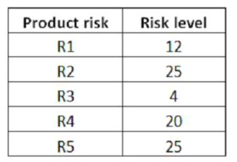Assume that you are the Test Manager for a small banking application development project.  
   You have decided to adopt a risk-based testing strategy and 5 product risks (R1, R2, R3, R4, and R5) have been identified during the quality risk analysis. The following table shows the risk level associated to these product risks (higher numbers mean higher risk):

55 test cases have been designed and implemented to cover all these 5 product risks. The coverage is described in a traceability matrix. This is the test execution status table, after the after the first week of test execution:  
About 56% of the planned test cases have been successfully executed.

Assume that no additional product risks have been identified during the first week of test execution.

Which of the following answers would you expect to best describe the residual risks associated with the identified product risks, at the end of the first week of test execution?

1. Since R3 is the only risk for which all test cases have passed, the risk has been reduced by 20%
2. **The test execution status table indicates that the risk has been reduced by 56%**
3. The residual risk level can’t be determined, because it requires that all the test cases have been executed
4. The test execution table doesn’t give an indication of the risk level of the open defects and the test cases that failed or are not run yet
5. Assume that the following test cases have been executed at the end of the first week of test execution: TC-001, TC-002 and TC-007. All these tests are ‘passes’.

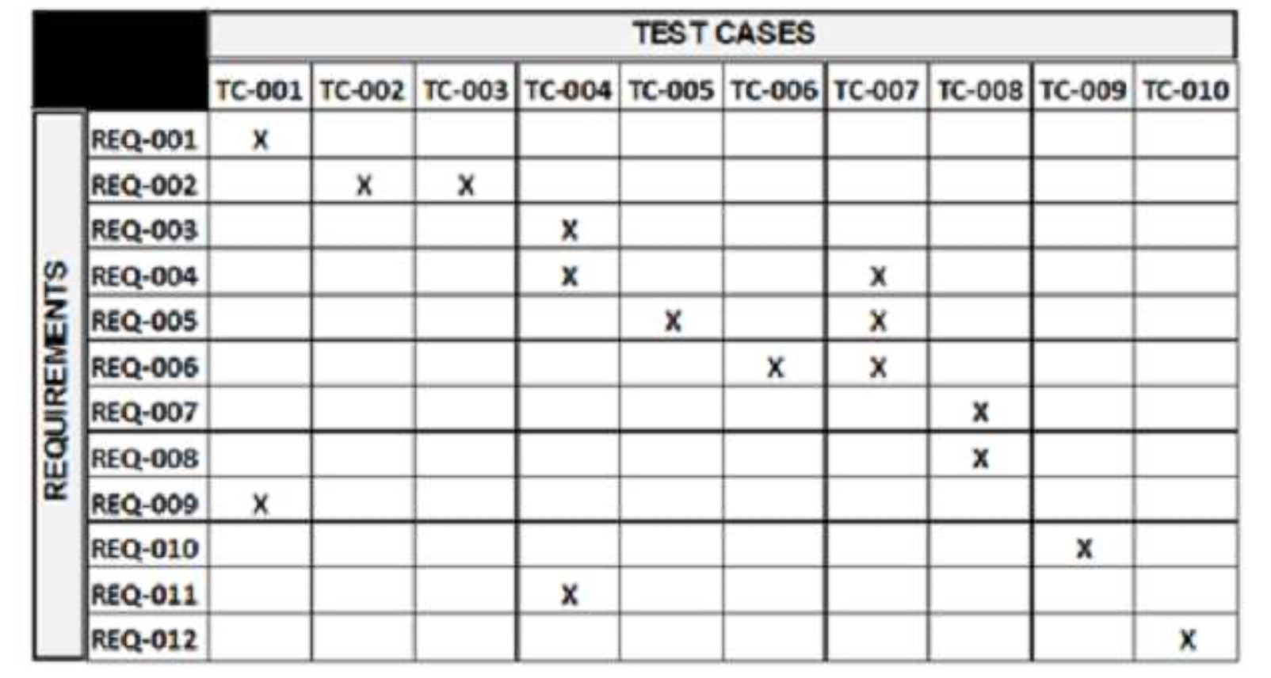

What is the MINIMUM number of the remaining test cases that must be successfully executed to fulfill the EX1 exit criteria?

1. 4
2. 5
3. **6**
4. 7

## TECHNICAL KNOWLEDGE

1. Select two tools used for API Testing?
2. **Postman**
3. **SoapUI**
4. Selemium
5. Visual Studio Test API
6. What is Team workspace in Postman
7. Collections are triggered automatically as per specified parameters whereas Postman
8. **Collaborative environment for a group of users to develop and test APIs.**
9. Monitors allows to import local variables
10. All answer

### What is a collection in Postman? (chose two)

1. Like Microsoft has One Drive
2. collaborative environment for a group of users to develop and test APIs. A team workspace is a workspace
3. **A collection is the grouping of requests, preferably of the similar types.**
4. It is one of the most vital feature of Postman and it also provides nice features such as running a whole group of request together with just one click

### Is a types of Request Method types

### Get

### Pet

### Put

### Send

### Pos

### define status code 401

### Created

### OK

1. Unauthorized

### Not Found

### What is Pre-Request Script in Postman?

1. Authentication is a process of presenting your credentials to the system and the system validating your credentials
2. A collection may have hundreds of requests under it.
3. **a script that runs before the execution of a request.**
4. end the information in a format that cannot be entered manually

### What is Jenkins?

1. command line interface to serve continuous integration
2. **project continuously and hence making the work of a developer and a tester easy for the software.**
3. project in which you can run any types of build
4. used with Postman normally as a command line
5. The main difference between continuous delivery and continuous deployment is the presence of a manual approval to update to production. With continuous deployment, production deployment happens automatically without explicit approval.
6. **TRUE**
7. FALSE

### What is Selenium ?

### API[Testing](https://www.guru99.com/software-testing.html)tools

### Web[Testing](https://www.guru99.com/software-testing.html)tools

### UNIT Testing tools

### All answers

#### What is test types that are supported by Selenium?

1. **Functional, Learn More about**[**Functional Testing.**](https://www.guru99.com/functional-testing.html)
2. Regression
3. Jenkins
4. Hudson
5. All answers

#### How you can use “submit” a form using Selenium ?

#### document.submit () ;

#### **element.submit () ;**

#### $(“button”).submit () ;

#### submit (element) ;

1. An object repository is an essential entity in any UI automations which allows a tester to store all object that will be used in the scripts in one or more centralized locations rather than scattered all over the test scripts.
2. **TRUE**
3. FALSE

#### Mention two different exceptions you had in Selenium web driver?

1. **WebDriverException**
2. **NoSuchWindowException**
3. NotException
4. DriveException

# PRACTICE

1. Create a test API with POSTMAN for next URL and attach export project
   1. <https://postman-echo.com> method= get with data test=”value” and other = “33”
   2. <https://postman-echo.com> method=post with values name, email and phone

for more information you can see <https://docs.postman-echo.com/?version=latest>

#### Create automatization test to Selemium and send video for

#### Login (<http://thedemosite.co.uk/addauser.php>)

#### SEARCH( http://automationpractice.com/index.php)